SCHOOL OF COMPUTER SCIENCE AND ARTIFICIAL INTELLIGENCE |  |  |  |  | DEPARTMENT OF COMPUTER SCIENCE ENGINEERING
ProgramName:B. Tech |  |  |  | Assignment Type: Lab |  |  | AcademicYear:2025-2026
CourseCoordinatorName |  |  |  | Venkataramana Veeramsetty
Instructor(s)Name |  |  |  | 1. Dr. Mohammed Ali Shaik  2. Dr. T Sampath Kumar  3. Mr. S Naresh Kumar  4. Dr. V. Rajesh  5. Dr. Brij Kishore  6. Dr Pramoda Patro  7. Dr. Venkataramana  8. Dr. Ravi Chander  9. Dr. Jagjeeth Singh
CourseCode |  |  | 24CS002PC215 | CourseTitle |  | AI Assisted Coding
Year/Sem |  |  | II/I | Regulation |  | R24
Date and Day  of Assignment |  |  |  | Time(s)
Duration |  |  | 2 Hours | Applicableto  Batches
AssignmentNumber:3.3(Present assignment number)/24(Total number of assignments)
 | Q.No. | Question |  |  |  |  |  | ExpectedTime  to complete
 | 1 | Lab 3: Prompt Engineering – Improving Prompts and Context Management  Lab Objectives:  - To understand how prompt structure and wording influence AI-generated code.  - To explore how context (like comments and function names) helps AI generate relevant output.  - To evaluate the quality and accuracy of code based on prompt clarity.  - To develop effective prompting strategies for AI-assisted programming.  Lab Outcomes (LOs):  After completing this lab, students will be able to:  - Generate Python code using Google Gemini in Google Colab.  - Analyze the effectiveness of code explanations and suggestions by Gemini.  - Set up and use Cursor AI for AI-powered coding assistance.  - Evaluate and refactor code using Cursor AI features.  - Compare AI tool behavior and code quality across different platforms.  Task Description#1  - Try 3 different prompts to generate a factorial function.  Promt1: give me the python code to generate factorial of number  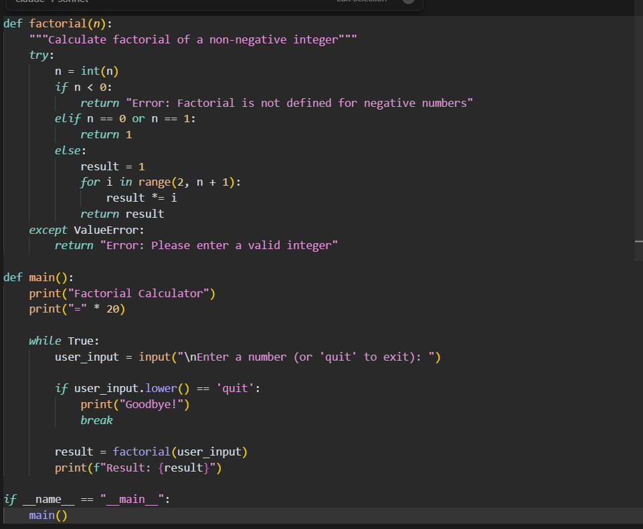  Prompt 1 output:  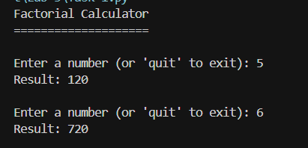  Prompt 2:write a python code to create a factorial of a given number.  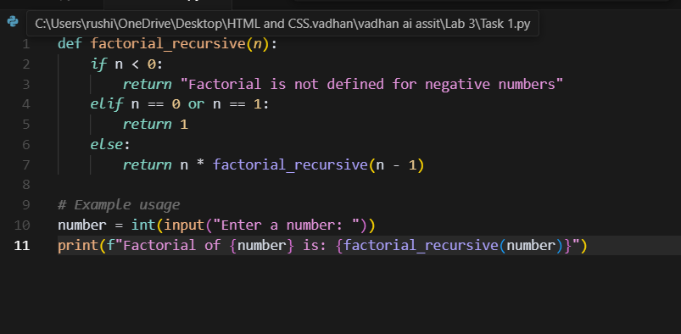  Expected Output:  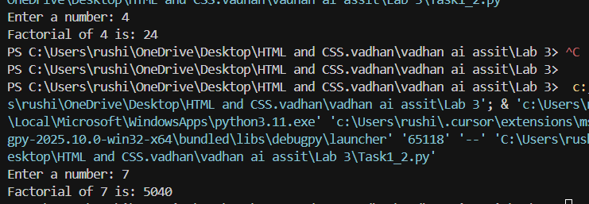  Prompt3:create a python code of factorial of number using iterative and ask the user to calculate the another number factorial.  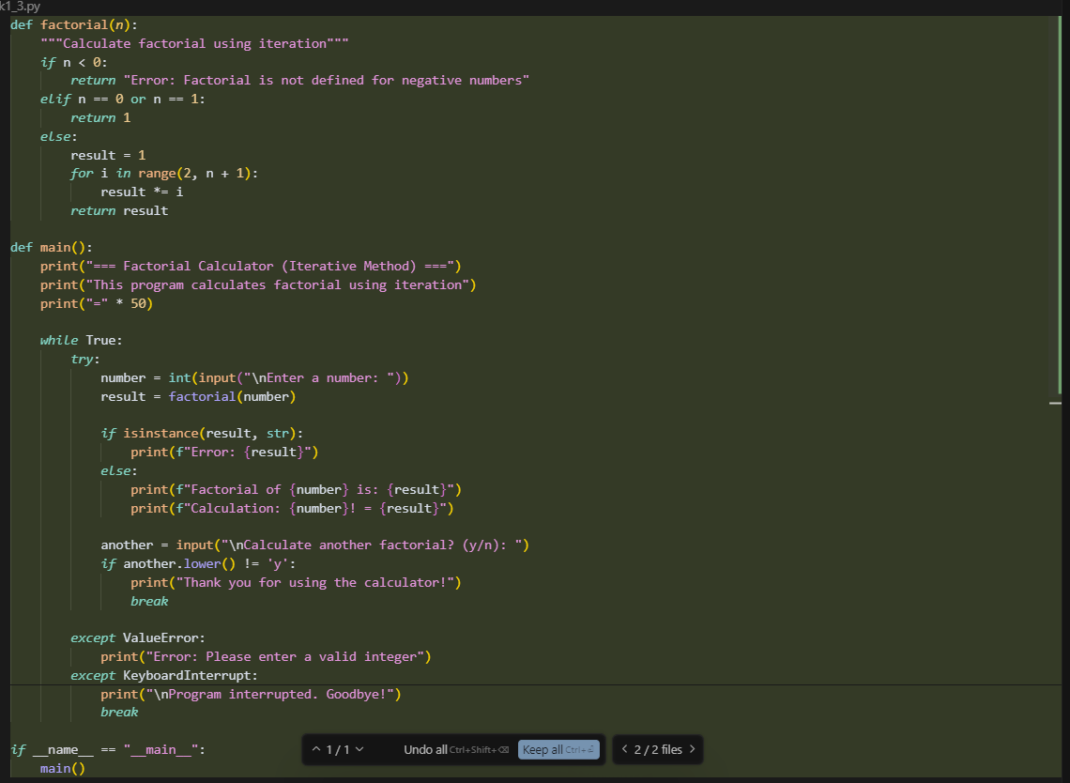  Expected output:  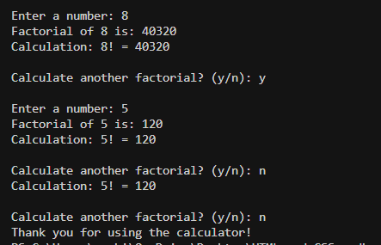  Report : In the task1.py I have done it user to enter only factorial 5 and 6 but in task1_2.py the code runs on the recursive function it asks the user to enter which number factorial we need after entering the number manually we get the result. Whereas in task1_3.py it runs on the iterative statement .it ask every time to enter the number to factorial as per the prompt.  Task Description#2  - Provide a clear example input-output prompt to generate a sorting function.  Prompt: write a python code for sorting functios which give clear input and output.  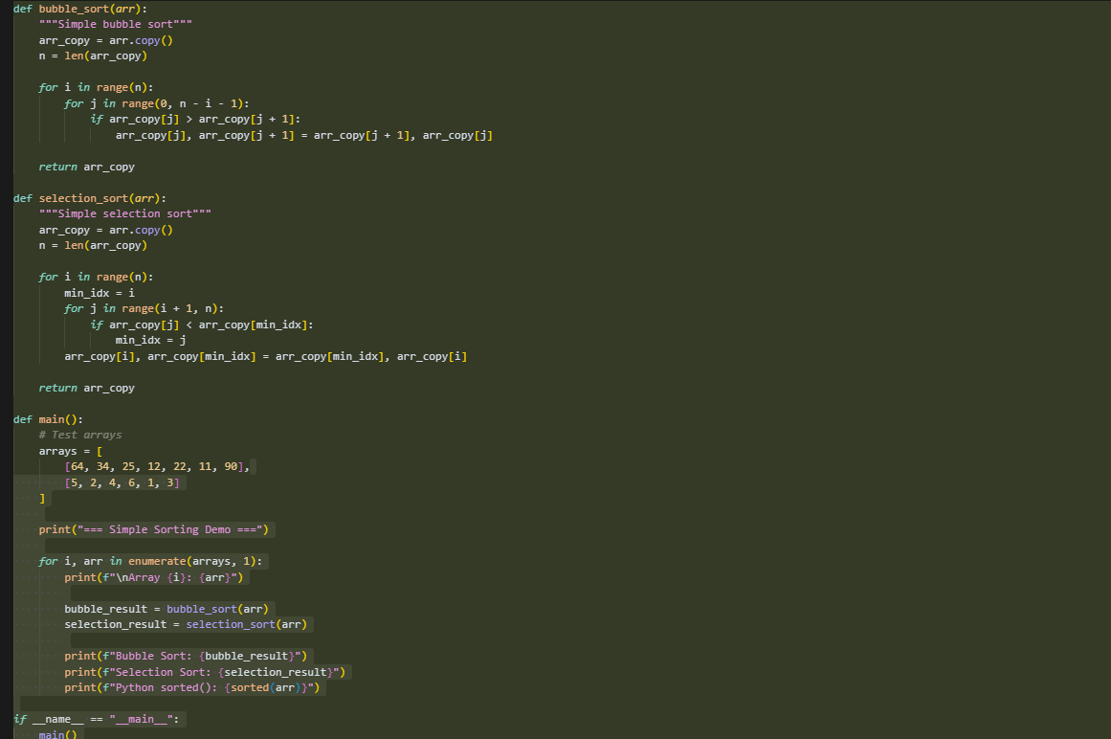  Expected Output#2  - Functional sorting code from AI  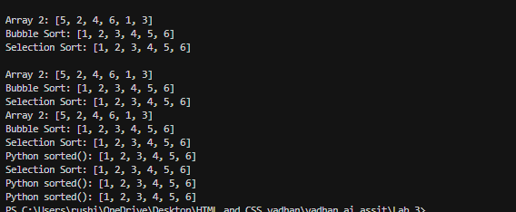  Task Description#3  - Start with the vague prompt “Generate python code to calculate power bill” and improve it step-by-step  Prompt : Generate the python code to calculate power bill  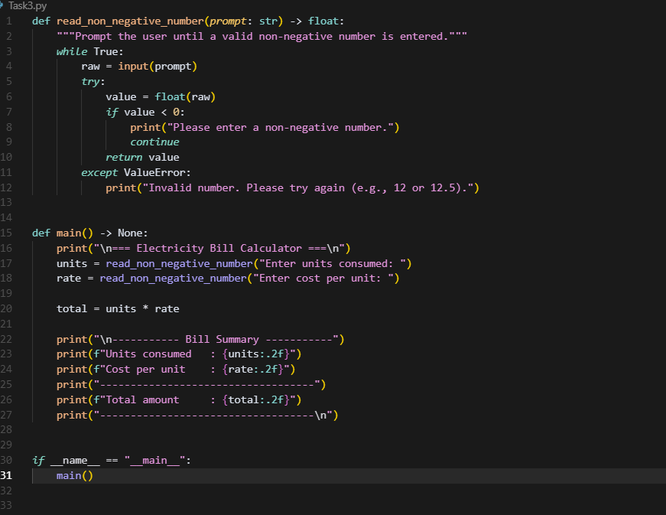  Prompt2:write a python code to create a current bill system with tax and user to enter the units , amount and tax percentage .  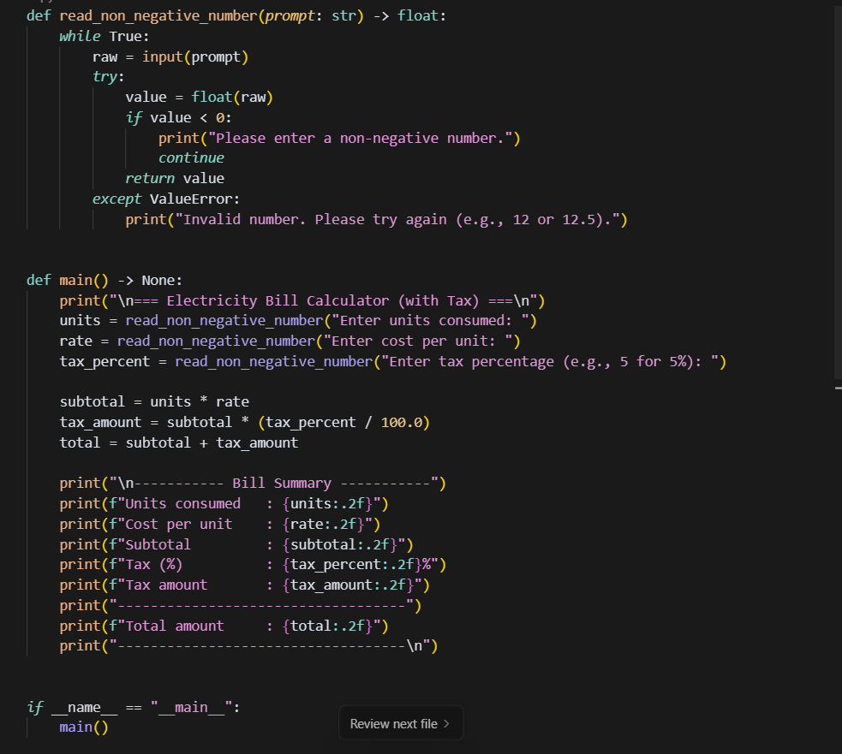  Expected Output#3  - Enhanced AI output with clearer prompts  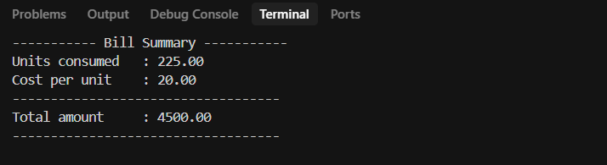  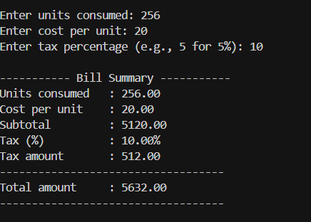  Report : in task3.py it asks enter the units and cost per unit and we enters it manually and then its gives the cost of current bill whereas in task3-1.py it asks us to enter the units after we need enter units cost per unit and tax then it gives the current bill that is total amount in the output.  Task Description#4  - Write structured comments to help AI generate two linked functions (e.g., login_user() and register_user()).  Prompt : Write structured comments to create a python code generate two linked functions login_user() and register_user().  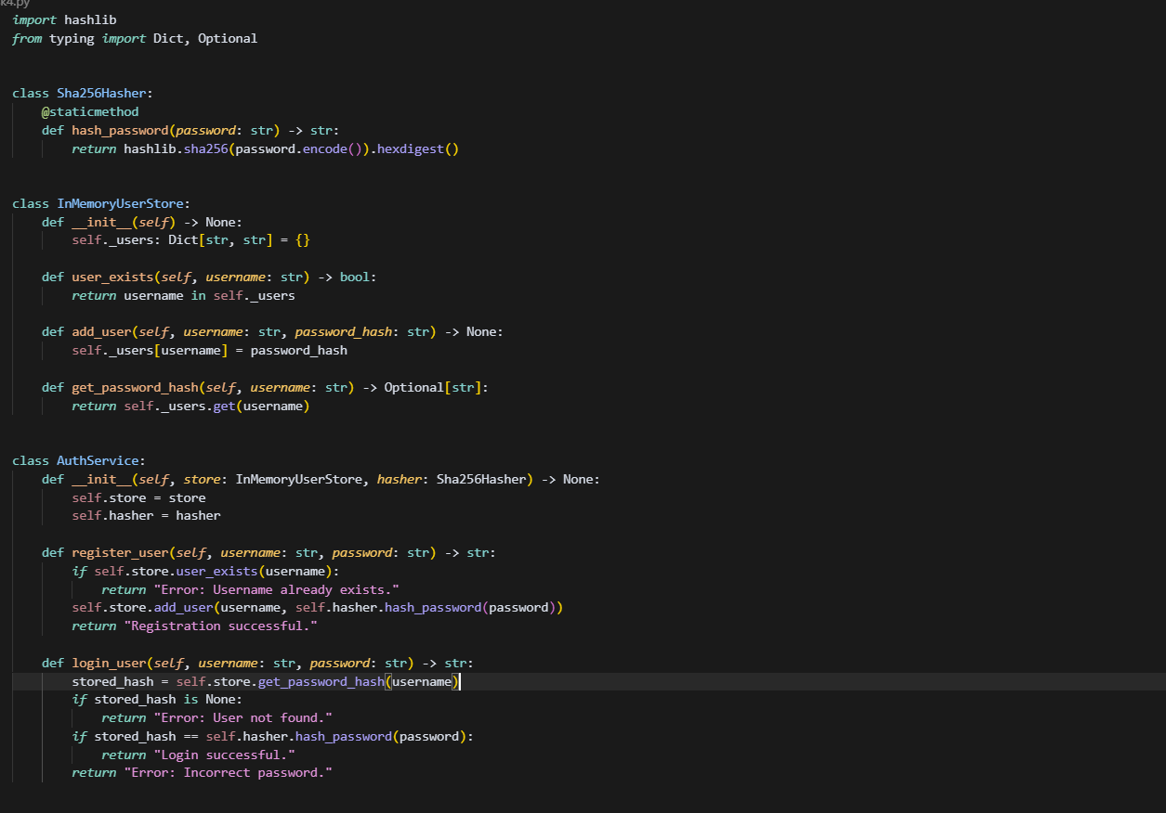  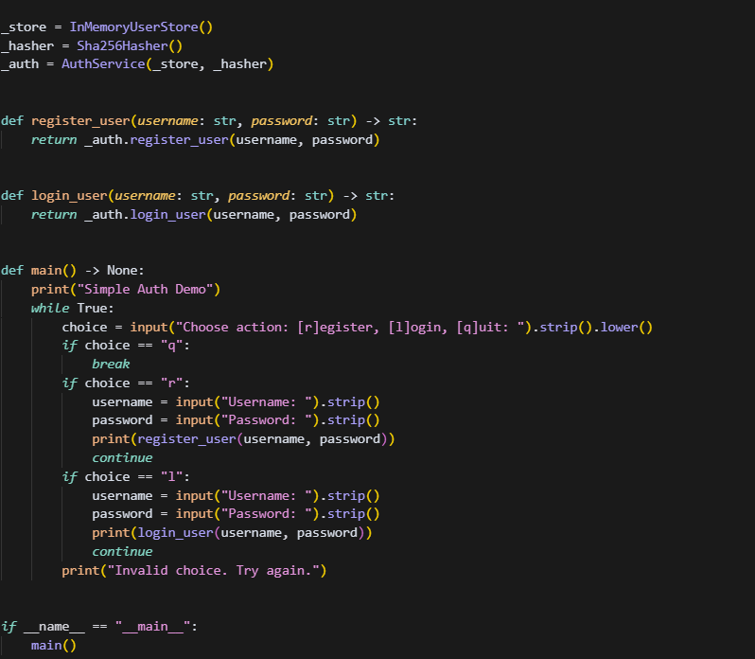  Expected Output#4  - Consistent functions with shared logic  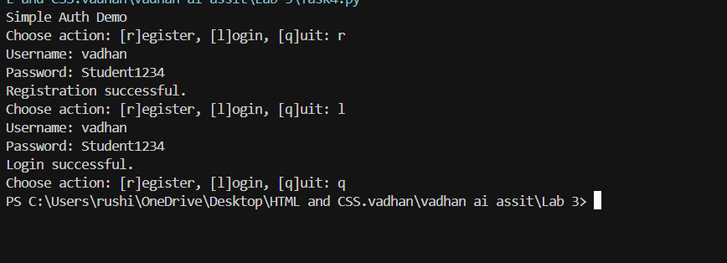  Task Description#5  - Analyzing Prompt Specificity: Improving Temperature Conversion Function with Clear Instructions  Prompt: give me python code to Temperature Conversion Function with Clear Instructions  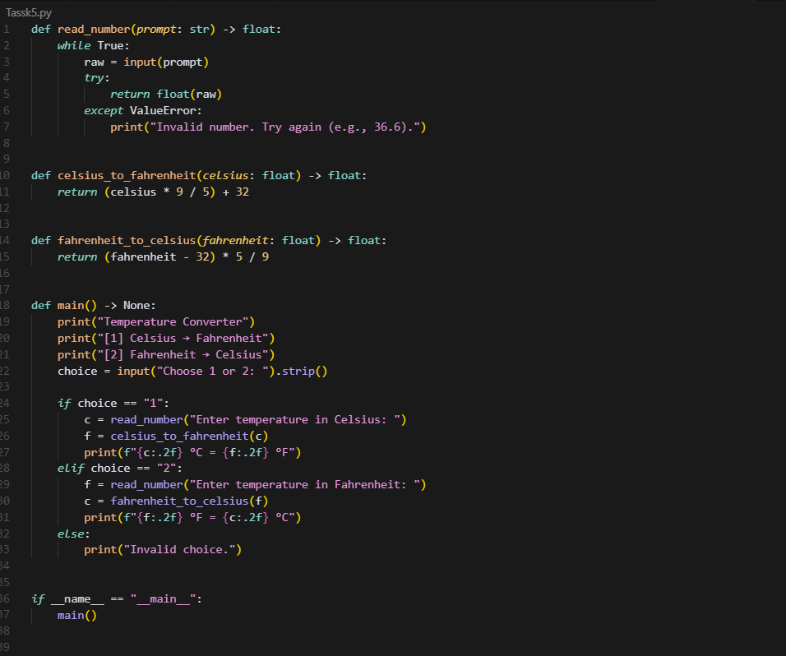  Prompt 2: write a python code to Temperature Conversion Function with 3 different temperature Celsius Fahrenheit and kelvin Ask the user to enter the temperature and conversion type.  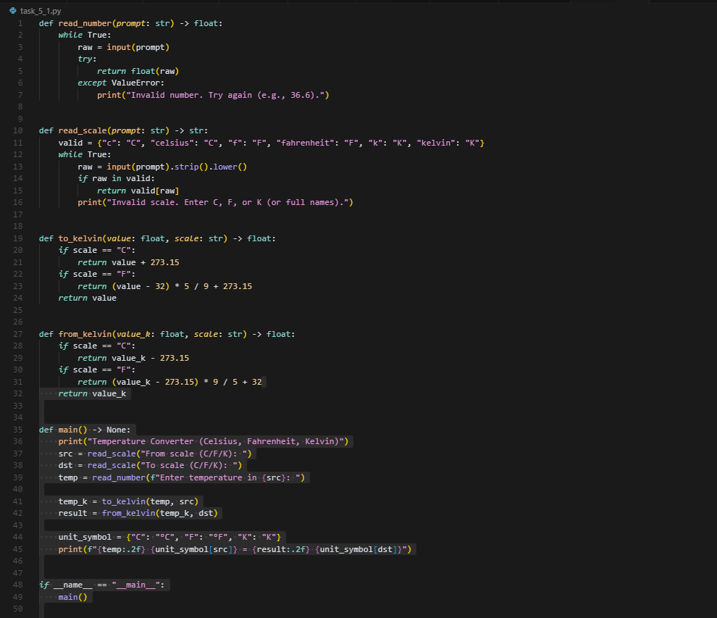  Expected Output#5  - Code quality difference analysis for various prompts  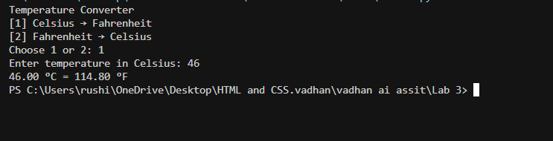  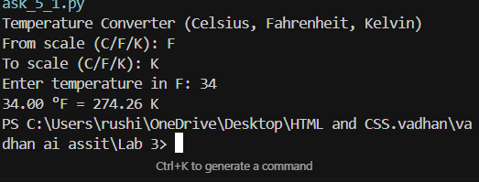  Report : In the task5.py I have done a temperature program in the basic way by adding only2 different scales like Celsius and Fahrenheit it is basic kind but in the task_5_1.py I have added Reaumur scale too and in the output with 3 different temperature conversion Celsius Fahrenheit and kelvin it asks the instruction like  1. Enter the temperature  2. from which scale  3. to which scale  If we add any thing invalid its shows invalid character  Note: Report should be submitted a word document for all tasks in a single document with prompts, comments & code explanation, and output and if required, screenshots  Evaluation Criteria:  Criteria Max Marks  Factorial Function (Task#1) 0.5  Sorting Function (Task#2) 0.5  Vogue Vs. Specific Prompting (Task #3) 0.5  Linked Functions (Task #4) 0.5  Temperature Conversion Function (Task #5) 0.5  Total 2.5 Marks |  |  |  |  |  | 03.08.2025 EOD

